

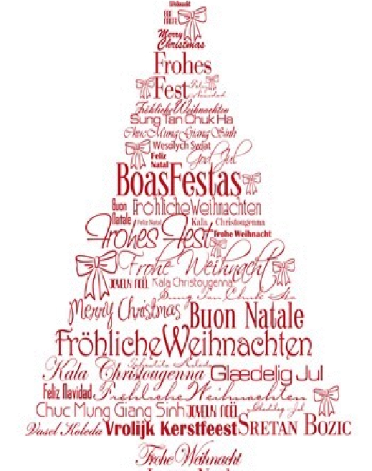
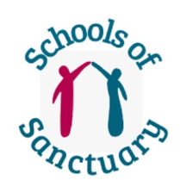





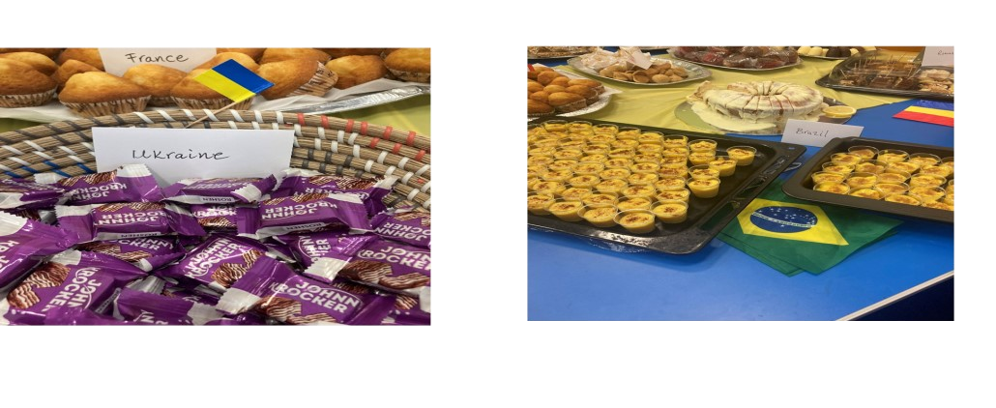

In November the
EAL Team hosted a
very
successful
‘
Multi
-
language
Day
’
a
Huyton
t
had
We
Library.
traditional
sweets and biscuits
from all over the world. Movema, the
group,
held
professional
a
dance
workshop teaching children and adults
dances from across the globe.

We were treated to different performances from local
primary schools. Willow Tree children performed in sign
language to two beautiful songs. St Joseph

the Worker
treated us to a touching performance where children
sang and danced to welcome a newly arrived Ukrainian
boy to their school. Children from St Margaret Mary’s
Junior School spoke about different experiences and
traditions from their home countries and dressed in
national costume. It was a fantastic way of showcasing
cultural diversity in Knowsley.

Thank you all for your support in 2023. It has been great for
us to celebrate the many cultural events together this year.
We look forward to working with you all again in the New
Year.

Have a wonderful Christmas break and best
wishes for 2024 from the EAL Team

Votos Calorosos!
!
کریسمس

مبارک

...

Ż
yczenia
Ś
wi
ą
teczne

¡Felices Fiestas!
S
ă
rb
ă
tori fericite

Ein frohes Fest!

Meilleurs voeux

致以节日的问候

ديعس

ديع

Nasladete se na
praznitsite!

In 2023 the EAL Team hosted several coffee afternoons in
Knowsley Libraries. It was a wonderful opportunity to get
together and meet EAL parents/carers and share experiences.
Parents were given information and advice about our
education system
-

hopefully having more knowledge and
understanding will help them to support their children during
their educational journey. We will be hosting more coffee
afternoons in the new year and hope to see you there.

School of Sanctuary Award

We are delighted to say that two Knowsley
schools have now been awarded School of
Sanctuary status: Knowsley Central and St
Joseph the Worker. A fantastic achievement!
Well done!

SOS is an award that demonstrates a school is a
safe, inclusive place for all children as well as
refugee and asylum
-
seeking children. We wish
all schools good luck in attaining this worthy award in the
future

Refugee Week 2023

In June 2023, the EAL Team hosted a cake sale
in Incredible Edible in Court Hey Park. We
raised £94.50 for Knowsley SHARe, a charity
who support asylum seekers and refugees
across the borough.

Eurovision 2023

We celebrated Eurovision and Ukrainian culture in
all our libraries during Eurovision week. Children
from
local
primary
schools
joined
in
the
celebrations with outstanding performances.

EAL

Knowsley Council

Newsletter

Dec 2023

EAL Coffee Afternoons

