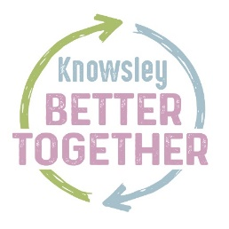



Knowsley Council
Travel Support Policy
2020 -2021

Contents
- Introduction

- Knowsley Better Together

- Appendices:

- List of legal definitions
- Early Years
- Home to School Transport
- Post 16 Home to College Transport (Travel support 16-19 and 16-25 with SEND)
- Children’s Social Care
- Adult Social Care
- How do I appeal my Travel Support Decision
- COVID-19 Arrangements

- Introduction
This policy sets out Knowsley Council’s approach to providing travel support for children, young people (including those aged 0 and 25 with Special Educational Needs and Disabilities) and adults who live in Knowsley. The policy outlines why we deliver services, what services we deliver and how they are delivered. It ensures that we are complaint with legislative obligations, delivering the best services for residents in a sustainable way.

What is travel support?
Travel support can help children, young people and adults to access the services and opportunities that meet their needs, such as education and training, as well as care services. Travel support can be provided in a variety of ways depending on individual needs but can include:
- Advice and guidance on walking, cycling or public transport options
- Provision of travel pass to enable independent travel
- Travel training and support to enable independent travel
- Travel by mini bus or specialist vehicle
- Travel in taxi or private hire vehicle
The Council has a statutory duty to provide some travel support services, for example children of compulsory school age who have particular needs and difficulties getting to school. Other services the Council provides are discretionary, meaning that the Council will assess and determine in accordance with this policy if transport is required in the applicant’s individual circumstances. As such service users may be asked to contribute towards the cost of this service.
Who is this policy for?
This policy includes all components of travel support that is currently provided by Knowsley Council, which are;
- Early Years -Pre School Children aged 0-4 years old (Appendix B).
- Home to school – Under the Education Act 1996 local authorities must promote the use of sustainable travel and transport for all children and young people of compulsory school age who travel to receive education in the local authority’s area. For more information on Knowsley Council’s Home to School policy please refer to Appendix C. Which also includes Children and Young People accessing education or training 0-19 or up to age 25 with SEND. (Appendix C and E)
- 16-19 Travel Support – Schedule 19 of The Education Act 2002 gives local Authorities responsibility for:
  - Preparing and publishing transport policy statements, following consultation with their partners, by 31 May each year. The policy statement should outline the transport support available for eligible students. For more information on Knowsley Councils Post 16 policy please refer to Appendix D.
- 19-25 Travel Support - Under the Education and Skills Act 2008 local authorities have a duty to encourage, enable and assist the participation in education and training of young people up to the age of 25 with special educational needs and disabilities. Appendix E. Furthemore section 508G of the 1996 Education Act places a duty on Local Authoritie’s to provide a policy on home to college transport support for adult learners.
- Children’s Social Care provides Travel Assistance to those children in need, where an assessment indicates this is approriate, this is underpinned by the following legislation;
- Children Act 1989
- Children Act 2004
- Adoption and Children Act 2002
- Leaving Care Act 2000
- The Framework for the Assessment of Children in Need and their Families
- Working Together to Safeguard Children 2018
More information can be found in Appendix F.
- Adults accessing Social Care services - This covers travel support arrangements for people over 18 who may be eligible for travel support from Adult Social Care Services in Knowlsey. The Care Act 2014 sets out the responsibilities Adult Social Care has in relation to travel support for adults and more information can be found in Appendix G.

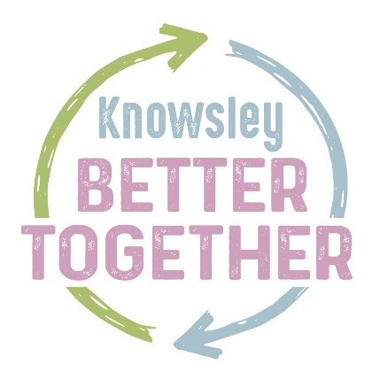
2. Knowsley Better Together
Knowsley Better Together is a way of working and shift in culture that is focused on the council working in equal partnership with residents, businesses, partners and the voluntary sector more than ever before.

It involves people coming together to share ideas, skills and time to achieve a shared goal or vision, improving outcomes for Knowsley.

This policy has been developed and will be delivered in line with Knowsley Better Together and the principles that underpin it.
These principles are:

- Be a strong community leader and always champion Knowsley
- Build better partnerships and work with others co-operatively to improve Knowsley
- Listen to the community when making decisions
- Spend locally, invest locally and recruit locally to build social value
- Help people to be independent, doing more for themselves and each other
- Prevent problems occurring or step them getting worse
- Use the best way of delivering services that leads to improved outcomes for Knowsley

In keeping with Knowsley Better Together, Knowsley Council has worked alongside a number of stakeholders in order to develop this policy. This has been achieved through formal consultation with:

- Headteachers, including special schools
- Knowsley Parent Carer Voice
- Children’s Safeguarding Board
- SEND Partnership Board
- Children and Families Board
- Heads of service and service managers
- Healthwatch and partnership boards
- Adult safeguarding board
- Knowsley Legal Department
- SENTAS (Special Eduication Needs Transport Advisory Service)
The wider population have also been consulted with through:
- Knowsley News
- Local Offer
- Knowsley Website
Working in a Better Together way, the Council will continue to ensure that the travel support services that the Council provides are personalised and match local needs. Recognising that the importance of personalised care, we will explore a range of options whilst making the best use of the resources available to us.

We will work to ensure that where travel support is provided, it will be done so in a way that promotes independence, considering an individual’s personal goals and outcomes, as well as their strengths and abilities.

Appendix A
List of legal definitions for terms in this policy:
Qualifying School- Qualifying schools are relevant educational establishments where the a pupil is receiving education by virtue of arrangements made under section 19(1) of the Education Act 1996. These are;
- Community, controlled, trust, foundation or voluntary schools;
- Community or foundation or Academy special schools;
- Non-maintained special schools;
- Pupil referral units;
- Maintained nursery schools;
- Academies;
- Studio Schools and University Technical Colleges (UTC):
- For children with a special educational need , an independent School can also be a qualifying school where it is named on the child’s EHCP or Statement or is the nearest of two schools named.

Definition of ‘Statutory walking distances’ –
This is two miles for children under eight, and three miles for those over eight (Section 444(5) of the Education Act 1996).
Definition of ‘Distance from home to school’ -
Distance will be measured by the shortest walking route from the main entrance of the child’s permanent home address (including flats and apartments) to the main entrance of the school using the Google maps. The road networks used to calculate distance are subject to change.
Measurements using other geographical systems such as Multimap, AA or RAC will not be accepted.
The Local Authority reserves the right to change the geographical measuring system at any time.

Definition of ‘Home Address’

This is defined as the permanent home address of the parent/carer. If parents/carers live at different addresses and both have parental responsibility, the address of the person claiming Child Benefit will be used to determine the child’s permanent address.
However, the Council will take into consideration 50/50 childcare arrangements and set childcare / custody arrangements can be accommodated within the current system. The offer of direct payments will form a firmer basis for children to continue to travel where this situation exists.
(Sentas is starting to get cases in other areas of the country where children live 50:50 with sepreated parents. LA’s are only providing transport to one address. We are arguing that this is incorrect on two counts:
- Especially secondary aged children are disadvantaged by refusal to provide transport from both addresses as if the child had no send would be able to travel to school independently from both homes.
- By refusing to provide transport from both homes the LA may potentially affect the amount of contact time a child may be able to spend with one parent or the other. Again this may place children with SEND at a disadvantage to chidren without SEND.
Parents/carers may be required to provide proof of residence in the form of a recent council tax bill, a utility bill, a tenancy agreement or exchange of contracts on a new home. Journeys between the home address and the designated drop off point may not be varied e.g. to a different drop off point without the express permission of the council.

There are children for whom the council may provide transport to and from school outside this definition, according to their individual circumstances. Examples of this could be children who attend overnight short break provision on a regular basis. This does not extend to situations where families may choose alternative pick up and drop off points.

Definition of Disability for transport support
Disability is as defined in Section 6 of The Equality Act 2010 as: a person has a disability if they have (a) physical or mental impairment, and (b) that impairment has a substantial long-term effect on their ability to carry out normal day-to-day activities. Therefore a chronic health condition may lead to eligibility under this definition.

Appendix B
Early Years
Who is this section for?
This section relates to children under the statutory school age (under 5) who have been assessed as having special educational need.
What support is available?
Knowsley Council does not ordinarily provide any assistance with home to school transport for children attending nursery/pre-school classes or for children who are under 5. This is because children under 5 travel free on buses, trains and ferries within Merseyside. Local Authorities do not provide any assistance to children who attend an independent (private fee paying) school.
The council may provide transport to children with SEND who are under 5 attending reception class in line with eligibility for school aged children with SEND in exceptional circumstances; such as children who turn 5 later on in the same academic school year. As such If a child has been assessed as having a special educational need then in exceptional circumstances the Council may be able to offer assistance dependant upon individual circumstance.
Is there a charge?
No. There are currently no charges for those accessing this service.
Who is eligible to apply?
As noted above, this service is not automatically available. Cases will be assessed on an individual basis.
How do I apply?
Please apply for travel support using the link below. https://transport.knowsley.gov.uk

Appendix C
Home to School Transport
Who is this section for?
This section is for parents/ carers of compulsory school aged children and young people who may be eligible for home to school travel support.
This section sets out the criteria for eligibility to travel assistance and describes how the Council fulfils its duties and exercises its discretionary powers.
Your child may be able to get free transport to school depending on how far the walk is, any special needs they have and whether the walk is safe.
All children between 5 and 16 qualify for free school transport if they go to their nearest suitable school and live a minimum of:
- 2 miles from the school if they’re under 8
- 3 miles from the school if they’re 8 or older

Families on low incomes
If you get the maximum Working Tax Credit or your children are entitled to free school meals, they’ll get free school transport if they’re:
- aged 8 to 11 and the school’s at least 2 miles away
- aged 11 to 16 and the school’s 2 to 6 miles away - as long as there are not 3 or more suitable schools nearer to home
- aged 11 to 16 and the school’s 2 to 15 miles away - if it’s their nearest school preferred on the grounds of religion or belief

Please note that proof of working tax credit or free school meal entitlement is required to support your application.

Route safety
When assessing route safety, the Council will consider a range of risks such as canals, rivers, ditches, speed of traffic and fields of vision for the pedestrian and motorist.

Children with special educational needs and disabilities (SEND)

Your child or young person is entitled to free transport if they cannot reasonably be expected to walk to school due to their SEND or mobility problem. The distance from your child’s school is not the only determining factor when assessing eligibility and is only a consideration when assessing any child’s eligibility.

We have outlined the below guidance as to what is deemed a reasonable distance to walk for your guidance. If your family home is within these walking distances further information/evidence will be required to support your application.
- 2 miles from the school if they have SEN or mobility problem and are of a primary school age
- 3 miles from the school if they have SEN or mobility problem and are of a secondary school age
In line with the relevant guidance an Education, Health and Care (EHC) Plan alone does not automatically qualify your child for transport assistance nor does not having one exclude them from travel support.

The following evidence can be provided to support a SEND home to school travel application;

- Evidence of SEND (Medical note/records, Dr’s letter, EHCP or other professional opinion that the child or young person has SEND) Dated within the last 12 months.
- Evidence that the child or young person cannot physically walk to school because of their SEND or mobility problem (Dr’s letter, statement from school, statement from social worker or other relevant professional) Dated within the last 12 months.
- In the event the child or young person can physically walk to school then evidence needs to be provided that they are unable to do so independently (Dr’s letter, statement from school, statement from social worker or other relevant professional) Dated within the last 12 months.
- If the child or young person is able to physically walk however is unable to do so independently then evidence needs to be provided that there is no suitable adult to escort their child to their place of learning. Where work commitments are cited as a reason for an inability to escort a child the council requires written evidence from the employer(s) that flexible working is not available to enable parent(s)/carer(s) to escort their child or young person to their place of learning.

Where evidence is not provided the Council will seek to obtain evidence in line with that mentioned within the application. This may cause delays when making transport eligibility assessments and transport will not be provided until evidence has been obtained. As such the LA will not be liable for any transport during the assessment of eligibility.
If appropriate evidence cannot be obtained within 28 business days then transport will not be provided and a refusal notification will be issued. During the above stated process Parents, carers and young people are expected to make transport arrangements until the Council has notified applicants of a decision.

If there’s no safe walking route
Children aged 5 to 16 must be given free transport if they go to their nearest suitable school and there’s no safe walking route, however far away they live.

Parents and carers are responsible for ensuring children and young people get safely to school on time. As a general rule Knowsley Council expects parents/carers of children and young people with SEND to make arrangements for their child to attend school in the same way as for parents without SEND as this is an important factor in developing the child or young person’s independence, social and life skills. The Council has a duty to make the most efficient and effective use of the resources it has available to it, whilst ensureing any transport provided is suitable for an eligible child.
What support is available?
- Bus pass, shared transport within a taxi or minibus, or individual taxi.
- Prior to transport being arranged parents/guardians/carers will need to complete an application form detailing the special travel requirements of their child.
- An appropriate type of transport will then be determined.
You will need to reapply for travel support if you change education provider.
Eligibility for transport should be reviewed annually or sooner if individual circumstance warrant this.
Independent Travel Training for Secondary School age pupils
During the service users’ education, Knowsley Council may request an assessment for suitability for Independent Travel Training at any point or during the applications process. Independent Travel Training is open to secondary aged children and adults whom are eligible for travel support. Pupils with special educational needs and disabilities will be supported through Independent Travel Training where appropriate and encouraged to develop their independence by using public transport.
Assessment will take place with parents, schools and other professionals regarding a child’s/adults ability to travel independently. The outcome of this assessment will be communicated to parents/guardians before any training commences. If parents/guardians refuse the opportunity for the child/adult to participate in independent travel training Knowsley Council’s offer of support will be to guide the parent/carer to commence their own travel training with assistance from the Council
If a pupil is deemed suitable to undertake Independent Travel Training, the cost of bus travel will be provided during the training programme for pupils not eligible for a Merseytravel Disabled Person’s Travel Pass. If the pupil has transport support this will continue on a temporary basis on the days not undertaking scheduled training, pending the outcome of the Travel Trainer report on completion of the programme.
For secondary school age pupils who are able to access public transport, following participation in the Independent Travel Training programme, a travel pass will be provided for the rest of the academic year in which training was undertaken to those pupils not eligible for a Merseytravel Disabled Person’s Travel Pass. Eligibility for a travel pass will be reviewed on an annual basis and a new application will be required.
If parents/guardian feel the assessment is incorrect they have the right to appeal following the formal appeal process (Appendix F). If the individual is unsuccessful at independent travel after a travel training program other travel support options will be explored such as shared transport within a taxi or minibus, or individual taxi. or other provision deemed reasonable to meet individual need.
Accompaniment
In determining whether a child cannot reasonably be expected to walk for the purposes of ‘special educational needs, a disability or mobility problems eligibility’ the local authority will need to consider whether the child could reasonably be expected to walk if accompanied and, if so, whether the child’s parent or legal carer can reasonably be expected to accompany the child.
When considering whether a child’s parent or legal carer can reasonably be expected to accompany the child on the journey to school a range of factors may need to be taken into account, such as the age of the child and their needs. Whilst one would not ordinarily expect a child of secondary school age to be accompanied, we would ordinarily expect a child/young adult to be accompanied if they needed support or assistance in managing their needs
The general expectation is that a child will be accompanied by a parent or legal carer where necessary, unless there is a good reason why it is not reasonable to expect this.
Alternative Addresses
Council Commissioned Transport will only be provided to the pupil’s home address for journeys at the agreed school start and finish times to approved address’s that are part of a child routine. (Additional or irregular journeys must be funded either by school or parents. For example additional school activities or appointments.
Parental childcare is the responsibility of the parent and not that of the local authority, parents/guardians are expected to make the necessary arrangements to be at their home address or for a responsible adult to be at their address at the estimated pick up and drop off times to transport providers. In some circumstances the Council may be able to accommodate set child care arrangements but this is approved on a case by case basis.
Is there a charge?
No, there is no charge for home to school transport where the above criteria and eligibility has been met.
Any travelling arrangements or expenses will be the responsibility of parents if there is a nearer suitable qualifying school. It is the parents’ or carers’ responsibility to ensure that their child gets to school safely and they should consider the practicalities of choosing a school that is not within the qualifying walking distance.

The flow chart below illustrates this process:
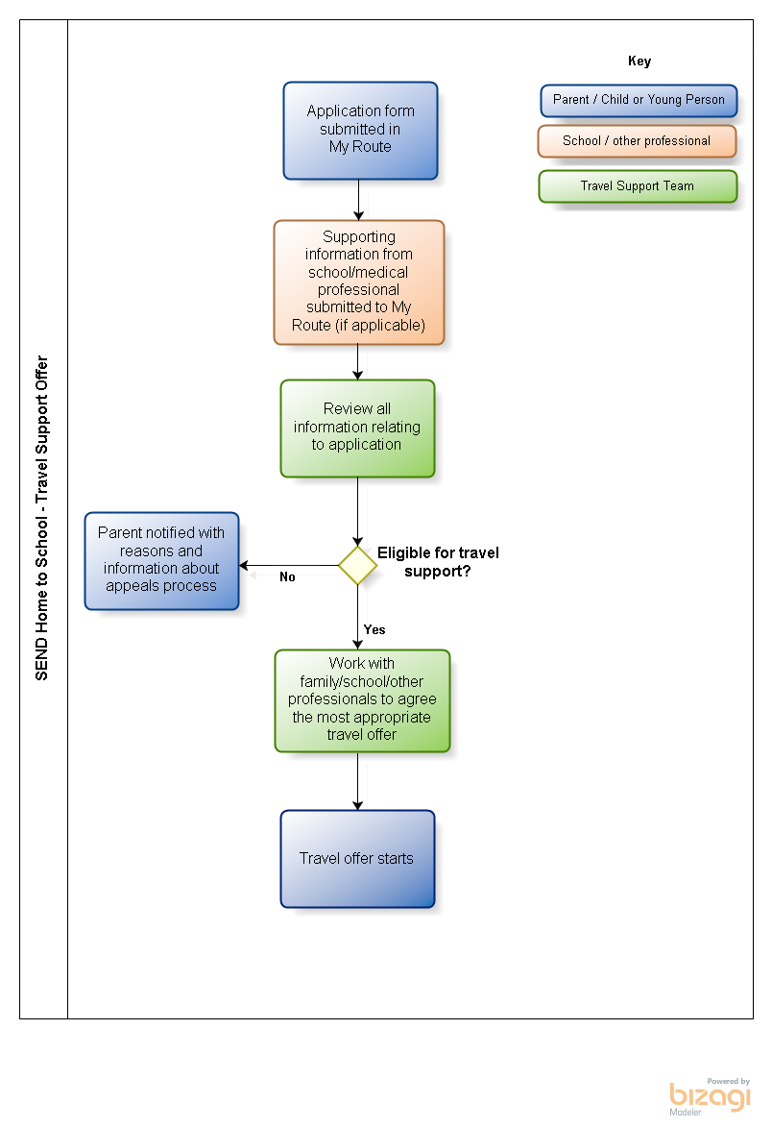

Appendix D

Post 16 Home to College Transport
(Travel support 16-19
and
16-25 with SEND)
Who is this section for?
This information is for learners aged between 16 and 19 living in Knowsley who are in full time education or training and pupils aged 16-25 with SEND who are in full time education or training. This cohort of pupils is refered to as “Post 16 Home to College Transport””.
All councils have a duty under Section 509AA (7) of the Education Act 1996 to publish annually a Transport Statement for students and learners aged 16 -18 and 19 to 25 if they have Learning Difficulties and/or Disabilities. Knowsley publishes one statement which covers all cohorts to whom the duty applies.
The information in this statement covers the transport arrangements for students and learners of sixth form age and those aged 19 to 25 with Learning Difficulties or Disabilities who live in Knowsley and who are studying or training at:
- Schools
- Further education sector institutions
- Authority maintained or assisted institutions providing further education
- Establishments funded directly by the Education Funding Agency or Skills Funding Agency, including independent specialist providers for learners with learning difficulties and/or disabilities.
- Learning providers that are funded by the local authority to deliver accredited programmes of learning which lead to a positive outcome (this could include colleges, charities and private learning providers).
What support is available?
Travel support queries for post 16 travel support in education or training are addressed in the Post 16 Transport Statement. This statement guides learners to the local and national transport services that are available, as well as those provided by education and training providers. The statement also gives information regarding what financial support is available and is updated annually
Is there a charge?
Individual colleges and training providers offer a range of travel options, at varying prices. All of the information for local provision is published annually in the Post-16 Transport Statement.
For services provided by Knowsley Council, there may be a charge per journey.
Who is eligible to apply?
Young people with transport who remain at a special school beyond compulsory school age may be eligible for free school transport until the end of the academic year in which they reach the age of 19, subject to annual transport reviews.

Knowsley Metropolitan Borough Council is not required to provide transport support for pupils with special educational needs or disabilities who attend school sixth forms or colleges of further education. However, support may be provided in certain circumstances, as set out below;
- Pupil has severe or complex learning difficulties than can be evidenced through the students EHC plan and the previous historical need resulted in entitlement to transport support

Or

- Has a physical and/or mental condition that can be evidenced with professional medical evidence and through the students EHC plan and the previous historical need resulted in entitlement to transport support

And

- Where the family is in receipt of income support or job seekers allowance and/or universal credit equivalent the following conditions apply:

- No assistance will be provided under this scheme for a student who is aged 19 or more when he/she begins a course of further education, a student attending a part time course or undertaking a higher education course.
- Provision is for one academic year only. A new application for transport assistance must be made for each subsequent year.
- Attendance must be at the nearest suitable further education college or school sixth form with a minimum distance of 3 walking miles and a maximum distance of 20 miles. Any student who chooses to attend an alternative beyond 20 miles will be responsible for their own transport costs.

Suitability of Courses

A student may wish to attend a college or school sixth form other than the nearest suitable one, because he/she considers that a particular course offers more suitability for him/her. In the case of A’ levels, for the purpose of considering an application for transport assistance, the Council defines a ‘suitable course’ as one where at least two or more subjects are available, unless the student can demonstrate that the third (or subsequent) subject is an essential requirement for a subsequent course or career. A similar test will be applied where a student is seeking to attend a more distant school or college in order to follow a particular syllabus within the same subject. Suitability of courses will be determined during the application process taking into consideration evidence provided.

Appendix E
Children’s Social Care

Who is this section for?
Home to school transport for looked after children
The educational attainment of children and young people in the care of Knowsley Council (looked after children) is a high priority, and it is the aim of the Council to ensure children and young people receive continuity of education.
For looked after children and young people who do not have an education and health care plan and who have an assessed need to attend school outside of the normal area where they live, whether in residential or foster care, it will be the responsibility of their carer to transport them to school and back. In exceptional circumstances, when this cannot be achieved alternative arrangements will be made.
For Children looked after who do have an Education and Health Care Plan the SEND service should provide home to school transport in the same way they would for any other child.
Arrangements should be made at the initial care planning meeting.
Transport to contact and other settings for looked after children
All efforts must be taken to secure safe and best value transport for looked after children, even when a rapid response is required or in the case of unforeseen circumstances.
Where possible, contact visits should be arranged as close as possible to where the child is living and/ or attending school.
Transport to family time visits
When necessary the Council will provide transport for parents to attend family time visits with their children. The Council will reimburse public transport costs for attending family time visits on presentation of a valid ticket or receipt, or will pay a pre agreed amount for petrol costs upon production of valid receipt.
Transport for parents attending Parenting Courses provided by the Authority by way of reimbursed bus fares on presentation of a valid ticket, in exceptional circumstances only.
When the need presents the Council will identify parenting courses and classes to offer parenting support. Travelling to and from the course/class is a parental responsibility unless safeguarding services identify exceptional circumstances in which case the Authority will reimburse travel expenses for personal car (at public transport rate of 16.4p a mile) or public transport use.
Other: There may be other circumstances when Children, Young people and their families are provided with transport on adhoc basis. This will be at the discretion of the child’s Social Worker and the Team Manager.
What support is available?
There are a range of options available. Discretion to attend meetings and appointments will be dependent on the assessed need of the child.
Is there a charge?
No.

Appendix F
Adult Social Care
Who is this section for?
If you have been assessed as having a social care need and eligible for support from Adult Social Care services then this section will give you the information you need regarding travel support.
Legal Framework
The Care Act 2014 places a duty on the council to meet the needs of adults and carers assessed as having eligible needs. However promoting wellbeing and meeting needs is not always about direct service provision, as other means of support may be more appropriate to meeting an individual’s eligible needs.
The Care Act 2014 does not place a duty on the local authority to provide transport. However if a person is assessed as requiring support to make use of necessary facilities or services in the local community (for example), and they are deemed to have eligible care and support needs, then the local authority does need to consider how a person might access facilities and services in the community. This means considering a range of transport options that might be available to them.
Assessment and Eligibility – Determination of Need, Care and Support
If a person contacts the council with a presenting need, a Care Act Assessment will be carried out in order to establish whether or not they have eligible needs for care and support. When assessing eligibility for transport and feasibility of different ways to access services, the following factors will be taken into account:

- Eligibility for care and support
A Care Act Assessment will be carried out in order to establish whether or not a person has eligible needs for care and support. The Care and Support Planning process should outline the need for and purpose of transport, and consideration should be given as to whether an individual’s eligible needs include the need to access and engage in the community and totravel independently or with assistance from family, friends or support providers. In this regard a principal of reasonableness will be adopted (the assessment will aim to establish if it is safe and reasonable to expect the person to make their own travel arrangements). As part of the assessment all transport options will be examined and the outcomes will be identified and evidenced.

Consideration will be given to transport in the initial assessment of a perons’s needs and any subsequent review and reassessment of care needs. Reassessments will take place at least annually, however an individual can request a review of their social care assessment at any time. Anyone receiving travel support at the time of transition from Children’s Services into Adult Social Care Services, will have transport considered as part of their initial Care Act Assessment.

- Identification of need in relation to accessing and engaging in the community
In working with people to meet their eligible needs under the Care Act 2014, Knowsley Council aims to ensure that independence is maximised, people are supported to make use of a range of community assets and resources, including their own strengths, those of their friends, families and communities, and that control over day to day live is promoted.

If there are no other ways in which the individual can reasonably access services and support, or be expected to make arrangements to access them safely, then the provision of transport by the council will be considered a need and transport will be arranged.

- Access to existing transport
A person will not normally be eligible for assisted transport if:
- They have a Motability vehicle which they drive themselves.*
- They have a motability vehicle of which they are not normally the driver.*
- They are in receipt of the mobility component of Disability Living Allowance or Personal Independence Payment (PIP), the purpose of which is to assist those who have mobility problems with severe difficulty walking or who need help getting around outdoors and in the community.
- They live in a registered residential care home.
- They can use public transport.
- They are assessed as able to mobilise safely to their destination, with or without mobility aids, either independently or with support from family, friends, support worker, volunteer etc. to get to a local community activity.
- They are able to walk.
- Transport can be provided by a family member or friend.
- A person contributes to a shared vehicle.
- A service user chooses to attend education or community facilities outside of their locality, and suitable service is available more locally.
- A service user is funded by another local authority to attend services in Knowsley.

*NB consideration will be given in exceptional circumstances where the requirement for the person to access and use a vehicle at certain times is not feasible due to other significant factors. This will be considered on an individual basis at the time of assessment.

- Assessment of mobility
A mobility assessment may be carried out to contribute to the decision regarding eligibility for transport. This will involve assessing issues such as:
- Ability to walk outside independently.
- Requirement for wheelchair or walking aid.
- Risk of falling without support.
- Ability to bear weight to transfer.
- Ability to get in and out of property.
- Ability to get in and out of a vehicle.
- Risk of fall or self-harm due to uncontrollable movements.
- Ability to use stairs, manage gradients, steepness of stairs in home, safety, energy levels.
- Any barriers to independent travel.
- Risks to others.
- Occupational Therapy or other professional assessments.

- Assessment of ability to travel independently
An assessment of a person’s ability to travel independently may be carried out to contribute to the decision regarding eligibility for transport. This will involve the consideration of:
- Extent of the mobility problems identified above.
- Availability of family, carers or volunteers to assist with access to transport.
- Communication difficulties (e.g. ability to order a taxi or use public transport).
- Psychological factors (lack of confidence, agoraphobia).
- Experience or risk of harassment.
- Any other factors affecting personal safety.

- Identification of appropriate transport provision for those eligible
The decision to arrange transport will be based on needs, risks and outcomes and on promoting and maximising independence. Where the council does agree to arrange transport, it will ensure that the transport provided is appropriate to meet the need and is the most cost-effective means of travel.

- Prioritise the use of local services to meet the eligible need

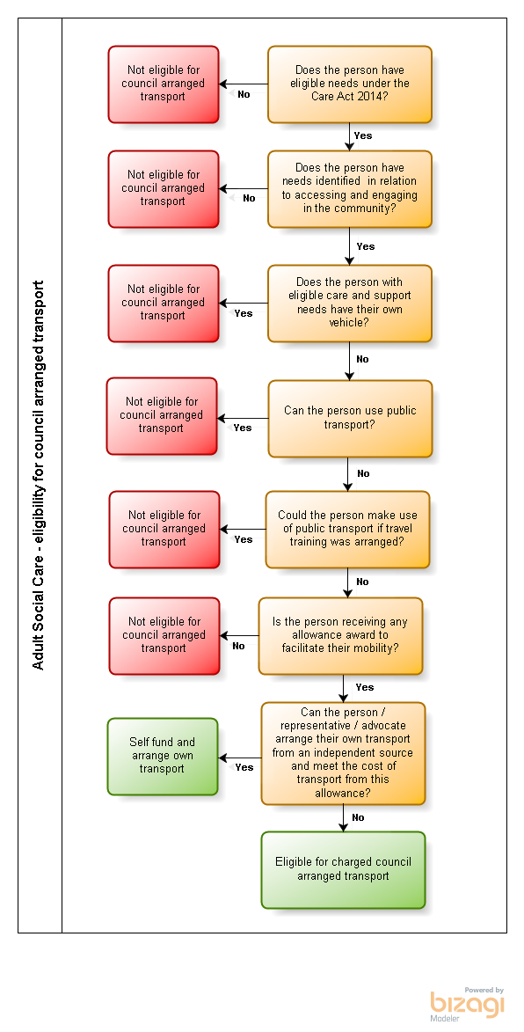
The flow chart below illustrates this process:

Is there a charge?
Yes, to ensure that as many people as possible benefit from the Council’s transport provision, the Council is only able to offer subsidised travel. Each journey will currently incur a standard cost of £3.
If a person receives a Direct Payment for the provision of transport, transport charges will be deducted directly from their Direct Payment. There is an expectation that the person will pay their transport charge directly into the dedicated Direct Payment account.
If a person receives commissioned transport by the Council, they will receive an invoice that can be paid in any of the following ways; Direct Debit, Standing Order, Cheque, cash at kiosks throughout the Borough, credit/debit card by phone or over the internet and bank transfer.
Transport is a discretionary service and cannot be provided unless the person’s transport charge has been paid and will be withdrawn where the person does not continue with this contribution.
Additonally, in order to maximise independence, some service users may be eligible to undertake independent travel training. There is a subsidised cost associated with this which will be dicussed upon enquiry.
How do I apply?
You do not need to apply separately for travel support; it will be considered as part of your Care Act Assessment.

Appendix G
How do I appeal a travel support decision?
A parent, carer or student who wishes to appeal against a decision not to provide travel support may do so via the Council’s agreed appeals procedures.
In line with statutory guidance, the appeal process has three elements:
- Stage One is a review of your case by the nominated officer. The parent/carer/individualwill receive a written notification of the outcome including details of how to escalate to Stage 2.
- Stage Two is a review of your case by the Travel Support Appeal Panel. The Appeal Panel is an independent panel comprised of Senior officers.
- Local Government Ombudsman (LGO). If the parent/carer is not satisfied with the outcome of the initial Stage 1 Review or any subsequent Stage 2 Appeal they may lodge a complaint to the Local Government Ombudsman. This can only be for them to consider whether there was any maladministration on account of the Local Authority.
Complaints
If you are accessing travel support for Adult Social Care Services and wish to challenge any decisions made, please refer to the Council’s Adult Social Services complaints procedure. Information regarding the complaints procedure can be found on Knowsley Council’s Adult Social Care Services website.
There are a number of ways to make a complaint to the LGO:
Telephone:
- Call 0300 061 0614 for help making a complaint
- Text ‘call back’ to 0762 481 1595
- Use a textphone via the Next Generation Text Service (formerly know at Text Relay and Typetalk)
Online:
- Log onto www.lgo.org.uk/make-a-complaint

Appendix H
COVID-19 ARRANGEMENTS
- Early Years, Home to School, SEND Home to School and Post 16 Home to College Transport (Travel support 16-19 and 16-25 with SEND)
---------------------
Applications: Applications for transport in the above areas are conducted via remote means. Therefore the COVID-19 pandemic has not impacted the council’s ability to assess and process new applications for transport in these areas.
---------------------
Service Delivery: Due to the governments “Stay at Home” message significant proportions of children and young people did not attend school following phase 1 of lockdown. This enabled transport for the above area to continue to offer a full service. For arrangements from September please see below.
---------------------
Transport Arragements September 2020: in line with the governments guidance applying to all dedicated home to school transport;
- Local authorities remain under a statutory duty to provide free home to school transport for all eligible children and to publish a transport statement detailing what travel assistance they will provide for young people over 16.
- Local authorities, working with schools, education institutions and transport operators as necessary, should identify the risks arising from coronavirus and must then work through the system of controls set out in this guidance and adopt measures in a way that addresses the identified risk, works in the local circumstances, and allows children and young people to attend school or their educational establishment.
- Social distancing guidance to passengers on public transport will not apply on dedicated home to school transport from the autumn term. We believe this appropriate because:
  - the overall risk to children and young people from coronavirus (COVID-19) is very low
  - they do not mix with the general public on those journeys
  - home to school transport often carries the same group of children and young people on a regular basis, and those children may also be together in school.
  - the predictability, which public transport does not afford, will allow for planning so that protective measures can be put in places.
- Allowing space between passengers, or groups of passengers, is nevertheless helpful where possible, but we know that transport capacity means that there are many circumstances in which this will not be feasible. Where it is not possible, other measures from the system of controls become more important.
- There is no requirement for children to sit with the group of children with which they are educated on school transport, but it is one of the measures that local authorities may choose to adopt if it works in the local circumstances.
- It is now the law that people age 11 and over must wear a face covering on public transport. This law does not apply to school transport.
As such arrangements from September are for Transport in the above areas to operate on a buisness as usual model with the following protective measures implemented;

- Minimise contact with individuals who are unwell
Parents must be advised that children or young people must not board home to school transport if they or a member of their household has symptoms of coronavirus (COVID-19). Children and young people should not routinely have their temperature taken. This is not a reliable method for identifying coronavirus (COVID-19).
If a child or young person develops symptoms whilst at school or their educational institution, they will be sent home. They must not travel on home to school transport. The school or educational institution should contact the parent who should make arrangements for the child or young person’s journey home.
In exceptional circumstances, where it is not possible for the parent to make arrangements for the child’s or young person’s journey home, home to school transport may be provided. The guidance on ‘safe working in education, childcare and children’s social care settings sets out what must be done.
Drivers and passenger assistants must not work if they have symptoms, or if someone in their household has symptoms. They must go home if they begin displaying symptoms whilst at work.
Anyone with symptoms must follow the ‘Stay at home: guidance for households with possible or confirmed coronavirus (COVID-19) infection’.
Children, young people, drivers and passenger assistants who have been in contact with someone that has developed symptoms whilst at school or on home to school transport do not need to go home to self-isolate unless they develop symptoms themselves (in which case, they should arrange a test) or the symptomatic person subsequently tests positive (see below) or if they have been requested to do so by NHS Test and Trace.
People must wash their hands thoroughly for 20 seconds with soap and running water or use hand sanitiser after contact with someone who has symptoms. If a person with symptoms has been in a vehicle that provides home to school transport, the vehicle must be cleaned with normal household disinfectant to reduce the risk of passing the infection on to other people. See the COVID-19: cleaning of non-healthcare settings guidance for information, including carrying out cleaning procedures and adjusting ventilation
- Clean hands thoroughly more often than usual
Coronavirus (COVID-19) is an easy virus to kill when it is on skin. This can be done with soap and running water or hand sanitiser.
Children, young people, drivers and passenger assistants should clean their hands, before boarding home to school transport and when arriving at school or home.
Drivers and passenger assistants may wish to use alcohol hand rub or sanitiser at intervals throughout the journey, and should always do so after performing tasks such as helping a child into the vehicle or handling a child’s belongings.
It should not normally be necessary for children or young people to clean their hands during the journey.
- Ensure good respiratory hygiene by promoting the ‘catch it, bin it, kill it’ approach
The ‘catch it, bin it, kill it’ approach is very important. Schools will be reinforcing this message with children and local authorities may also wish to consider reinforcing it in their communication with families.
Children should be encouraged to carry tissues on home to school transport.
Some children and young people with complex needs will struggle to maintain as good respiratory hygiene as their peers, for example those who spit uncontrollably or use saliva as a sensory stimulant. This should be considered when deciding what safeguards should be put in place in order to support these children and young people and the staff working with them. (See section 5 below for more information.)
- Introduce enhanced cleaning, including cleaning frequently touched surfaces often using standard products, such as detergents and bleach
Coronavirus (COVID-19) is easy to kill on surfaces. Normal cleaning products will do this, specialist cleaning products are not needed. See the COVID-19: cleaning of non-healthcare settings guidance and the ‘Keeping public and private areas and modes of transport clean’ section of the transport operator guidance for information on carrying out cleaning procedures and adjusting ventilation
Local authorities should work with transport operators to agree the arrangements for cleaning vehicles. PHE recommend that frequently touched surfaces are cleaned quickly after each journey wherever possible – although this is not mandatory – and that enhanced cleaning takes place at the end of each day.
- Minimising contact and mixing
The guidance for schools recommends that educational settings should minimise contact and mixing by implementing ‘bubbles’ - groups of children between which mixing is minimised. It is for schools to determine how they will do this but, in secondary schools, particularly in Key Stage 4 and 5, groups may be the size of a year group. At primary school, and in Key Stage 3, schools may be able to implement smaller groups the size of a class.
Similarly, the guidance for further education and skills providers recommends that they reduce contacts between individuals through forming groups or cohorts of learners that remain separate from each other during the course of the day.
The guidance for schools acknowledges that implementing bubbles will still bring benefits even if implemented partially, and that schools may need to allow mixing into wider groups in certain circumstances including on transport. Siblings may also be in different groups.
Local authorities should work with schools and transport operators to consider how mixing might be minimised on school transport. However, we know that vehicle capacity and the complexity of some home to school transport arrangements, mean there will often be limits to the extent to which mixing can be minimised.
Measures which local authorities might consider are listed below. None are mandatory. We acknowledge that, in many circumstances, distancing and grouping may simply not be possible. Where they are not possible, other measures in the system of controls become even more important. It is for local authorities, working with schools and transport operators, to decide on the appropriate package of measures for their circumstances.
- Personal protective equipment is not normally needed on home to school transport
Drivers and passenger assistants will not normally require PPE on home to school transport, even if they are not able to maintain a distance from the children and young people on the transport. This is because, as set out above, children and young people with symptoms of coronavirus (COVID-19) must not board home to school transport, they should stay at home and get a test.
Where the care a child or young person ordinarily receives on home to school transport requires the use of PPE, that should continue as usual.
Reference to PPE generally means:
- fluid-resistant surgical face masks
- disposable gloves
- disposable plastic aprons
- eye protection (for example a face visor or goggles)
See also ‘How should I care for children who regularly spit or require physical contact’
---------------------
Annual Review: Due to COVID-19 the council may be unable to fully review exisiting transport arrangements. For example to ability to observe pick up and drop off arrangements at a set venue is impaired. We will however continue to liaise with parents, young people, carers, schools, transport providers and other professionals to ensure arrangements remain fit for practice.

- Transport arranged by Children’s Social Care
Service Delivery: Due to the governments “Stay at Home” message services were delivered remotely and there was no need to transport children and their families to appointments or meetings. The service was able to keep in touch with children and families and involve them in meetings remotely.
---------------------
Transport Arrangements as lockdown eases: in line with the governments guidance face to face meetings are limited. Direct family time between children and their families is now taking place. Children are transported by their carers and so there is no additional risk from the transport arangments. Parents and other family members travel in their own vehicle or by public transport following government guidelines - guidance to passengers on public transport .
---------------------
Transport in exceptional circumstances: There will be occasions when as a result of family circumstances children’s social care is required to provide transport either by taxi or by a member of staff transporting the parent or child. This will not happen if any individual involved is displaying any symptoms of COVID 19. Taxis will be provided when necessary and transport operator guidance will be followed. This will be the responsibility of the taxi provider. Taxis will be booked in line with council commissioning arrangements.
For staff transporting children or parents in exceptional circumstances, there will be a risk assessment completed. This assessment will include mitigating factors such as the use of face coverings, good hand hygiene, and good ventilation, sitting passengers in the back and limiting the number of people transported. Cleaning of non-healthcare settings guidance will also be followed.

- Adult Day Services

- Day Services will provide some transport, where this is deemed essential for a client to attend for their improved health and wellbeing, although we will be unable to adhere to the 2-meter distancing during these times
• When picking up/dropping off the member of staff does not enter the home to reduce risk of transmission
• Vehicles have been fully valeted before re-opening of services.
- Vehicles are cleaned after each use paying particular attention to ‘high touch areas’
• Weather permitting, windows will be opened during transport top ensure adequate ventilation
• All drivers will wear a face mask
• Vehicles will contain hand sanitiser for use when getting into vehicle
• Clients will be asked to wear a face mask for their journey. KMBC can provide a supply of masks for use, if required
• Routes will be planned to reduce length of time in vehicle to minimum
• Vehicles will have reduced occupancy and no-one will sit directly opposite face to face
• There will be no transport provided outside of the buildings during support/operational hours, unless agreed within support packages.

