
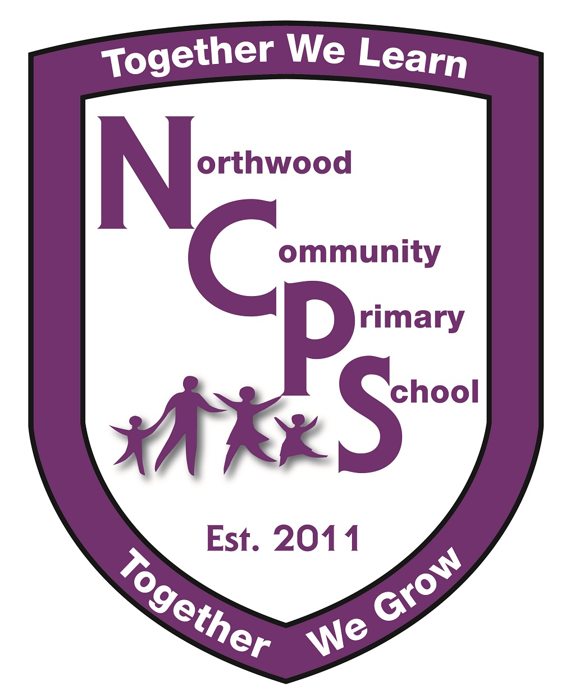


Northwood Language Hub
School Name
Name of Referrer
Designation
Telephone Number
Email Address

PERSONAL PUPIL DETAILS
Full Name
Year Group |  |  | Date of Birth
Address
Postcode
Primary Spoken Language |  |  | Sex |  |  | M |  | F
Religion/Belief |  |  | Ethnicity
Entitled to Free School Meal |  | Yes |  |  | No
Parent/carer (with parental responsibility)
Relationship to child |  |  |  | Contact number

REFERRAL PROCESS
Initial referral Date
Early Help Assessment in place | Yes | No | Date Started
Pupil is a Child Looked After | Yes |  | No
Pupil is on a Child Protection Plan | Yes |  | No
Is the child on the SEN register at SEN Support | Yes |  | No
Attendance | %
Name of Speech and Language Therapist

PUPIL PROFILE
What specifically has led to this referral?
Pupil Strengths and Interests (incl. curriculum strengths & interests)
Areas of Communication Need (describe specific difficulties /needs in each relevant area)
Expressive Language

Receptive Language

Attention & Listening skills

Speech sound system

Non-verbal communication Skills

Social communication Skills

Other Area (please specify)

Learning Profile of child (can be attached separately if necessary)
Complete only EYFS OR KS1 depending on the age of the child.
Learning Behaviours/Characteristics of Effective Learning (comment on how the child learns, resilience, stamina, problem solving, collaboration skills etc)

EYFS: (comment on prime areas + Literacy and Maths and give current attainment data)

KS1 (comment on reading, writing, maths, science and GPS and give current attainment data)

Additional School Interventions E.g. Sensory diet / phonic group (previous 12 months)
Dates | Duration | Type | Impact

Additional Learning or Medical Needs
Does the pupil have a medical condition / identified / diagnosed SEND needs?

MULTI-AGENCY PROFILE
Agency | Practitioner | Past 12mths | Current | Report  Y/N | Brief description of intervention – all available reports must be attached

School Contacts
Signature of referrer |  | Date
Headteacher Signature |  | Date

Agreement to share information
- I/We understand that the information I/we give will be used to get the services to help my child.
- I/We understand that the information I/we have provided may be shared only where it is necessary and the law allows it. The information may be shared with other teams and services.
- The teams and individuals that will have my child’s information will be the those who will be helping and supporting him/her. They will be named in any plans of support.
- I/We understand that under no circumstances will you share personal information with third parties for commercial purposes.
- I/We understand that information that I/we give is kept safe and secure and treated confidentially.
- I/We understand that my information will only be shared without my/our permission to protect children or vulnerable adults from harm; or to aid the prevention and detection of crime.
Parent/Carer Name |  | Date
Parent Carer Signature

All sections of the form must be completed providing as much information as possible. Missing or lack of information will delay access to the requested support.

There MUST be evaluated evidence of school-led graduated approach BEFORE a place in the Language Hub will be considered.

Referral Checklist:
Have you included…?
Referral form with parental signature? | Yes | No
Pupil’s current communication plan / S&L therapy care plan? | Yes | No
Pupil’s evaluated communication plans / S&L therapy care plan? | Yes | No
Evidence of school led graduated approach – play plans / PPP’s attached? | Yes | No
Most recent report from Speech and Language Therapist? | Yes | No
Other recent and relevant professional reports e.g. Educational Psychologist, Community Paediatrician? | Yes | No

Return to: LHUB@ncps.co.uk

