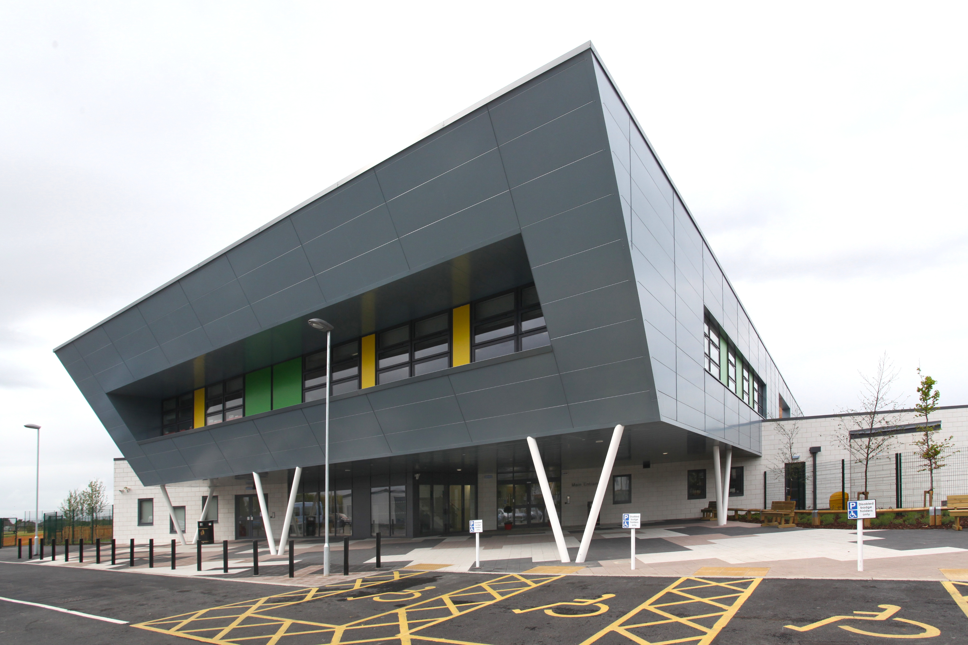
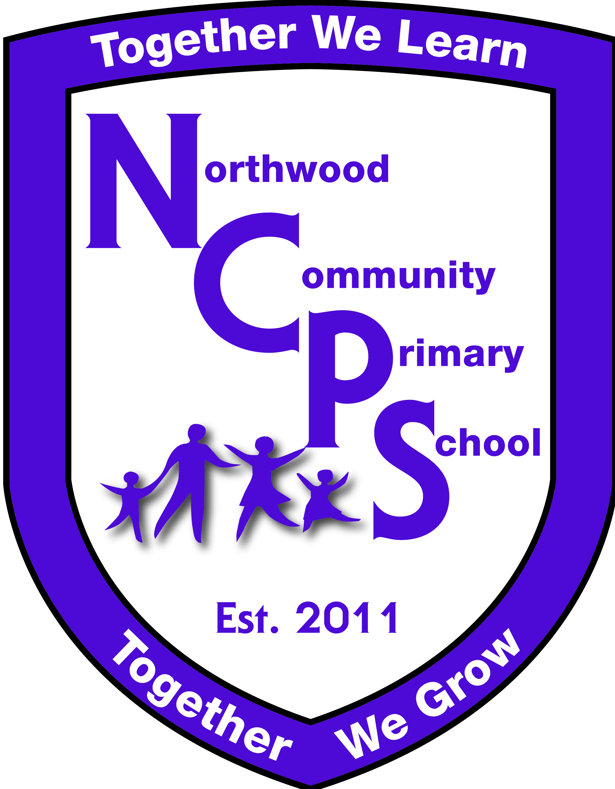
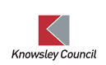
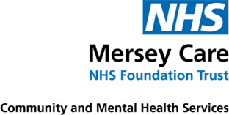

The Language Hub

Northwood Community
Primary School
Northwood Community Primary School Language Hub

Northwood Community Primary School is a unique 21st Century learning environment where pupils of all abilities are able to thrive and achieve their full potential. Within Northwood Community Primary all children are provided with stimulating and enriching learning opportunities. We work hard to engage and challenge our pupils and have a positive, personalised and inclusive approach to learning throughout the school.

Northwood Primary is a central part of the community and has an open-door policy which warmly welcomes parents/carers into the life of the school. Parental engagement and support is a key factor in educational success, and we offer a range of family support services and induction, transition, celebration and academic review events for wider families to attend. We provide a range of childcare from 0-11 years in collaboration with our onsite PVI Nursery provider, ‘Kids in Bloom.’

Language Hub Provision
At Northwood Community Primary School we are able to offer a unique specialist provision for pupils with specific language difficulties such as receptive or expressive difficulties. Our Language Hub Provision serves pupils from across the Knowsley area. We work in consultation with Knowsley Council and the Speech and Language Therapy service to ensure that the children who are placed in our Language Hub will benefit from the specialist learning environment that we provide and are supported to reach their full potential.

Our aim is the early identification of children with specific language difficulties so that they can benefit from an intensive, time limited period of support in our provision and then return to their home school successfully and confidently.

Safeguarding
Our DSL is Ms. Sarah Murphy. All staff are fully trained in the latest changes in KCSIE and follow robust safeguarding procedures. If you have any concerns please talk to us. Any issues will be resolved transparently, fully involving NCPS, home school and parents/carers.
Referral Criteria for a Place in the Language Hub

Speech, Language and Communication Need

- The pupil presents with Developmental Language Disorder or exhibits severe receptive or expressive language difficulties

- The pupil exhibits a severe speech sound disorder

- Speech, Language and Communication has been identified as the primary need at the time and not secondary to any other need [the pupil has not been identified as having any underlying learning need or their language disorder is not associated with a diagnosis of ASC]

- There must be evidence through Speech & Language Therapy assessments/ reports that the pupil would benefit from a place in the provision.

- The pupil will have accessed a period of intervention within the community. There is evidence to suggest they will be responsive to Speech and Language Therapy interventions. The needs identified require a more intensive level of input and a Total Communication language environment.

- Pupils will be at SEN support level for their speech, language and communication needs. An Education Health Care Plan may be considered during their placement if their needs are likely to impact on their access to education long term.

- The pupil will have accessed school-led support/intervention as part of the graduated approach for their speech, language and communication needs. Evaluated evidence of this will be submitted at the point of referral.

- Must attend a Knowsley school

Presenting Needs

The following list is not exhaustive, but pupils may present with:

- Poor verbal language/vocabulary

- Severe difficulty putting thoughts into grammatically correct sentences.

- Severe disordered speech resulting in unintelligible speech

- Pupils may resort to pointing or gesturing to communicate

- Severe difficulty describing, defining, explaining, and in retelling stories/events

- Limited vocabulary resulting in the pupil using empty phrases and non-specific words

- Functional words are omitted such as ‘the’ and ‘is’ & grammatical markers such as tense endings

- Difficulty in the understanding of multiple word meanings

- Difficulty with establishing & maintaining peer relationships

- Difficulties understanding verbal language

- Difficulties with processing and retaining auditory information

- Struggles following instructions and directions

- Struggles answering questions related to a limited understanding of question forms

- Struggles to filter out background noise / sound discrimination

- Poor verbal reasoning

- Finds imaginative play and social use of language challenging

Language Hub Classes
The Language Hub Provision is made up of two classes of pupils from Reception and Key Stage 1. Children will come to the Language Hub from their home schools for 4 days per week (Monday- Thursday) to benefit from intensive communication and language support. They will return to their home school on Fridays to maintain links and friendships. Before entering Northwood Language Hub, a period of transition will be put into place to ensure each child feels safe and secure in their new learning environment. Children will be seen regularly by the community Speech and Language team, who will set specific targets for children to work towards. Teachers and Teaching Assistants will collaborate with Speech and Language professionals and incorporate these targets into daily educational provision for each child and regular review meetings will be held to discuss progress. When a child is ready to leave, carefully planned transition back to their home school will be put into place.

Classroom organisation and teaching methods take account of the individual learning needs of the pupils and various strategies and techniques are employed by our dedicated staff team. We are committed to ensuring our staff have the best training possible and regular CPD ensures staff have the latest skills and knowledge at their fingertips to support our children. Staff are trained in Kagan, ELKLAN, Read Write Inc, Power of Reading, Maths no Problem Approaches, Makaton, Sensory Integration techniques and Communication and Language support strategies. We employ our own SALT on staff, although children in the LHUB are seen frequently by the NHS Speech and Language Team and we have a fully trained Sensory Integration Specialist Teacher on staff. We have purpose-built classrooms, language therapy rooms, sensory playgrounds designed to explicitly support the needs of our children and a soft playroom and sensory room to support the learning and development of our children.

Referral Process
Complete all parts of the Pupil Information Form and attach any additional information/assessments/reports and email to: LHUB@ncps.co.uk

Mark the email subject clearly as, ‘Language Hub Referral.’ Your referral will be discussed at the next panel meeting and you will be notified of the outcome and next steps as soon as possible after panel has met.
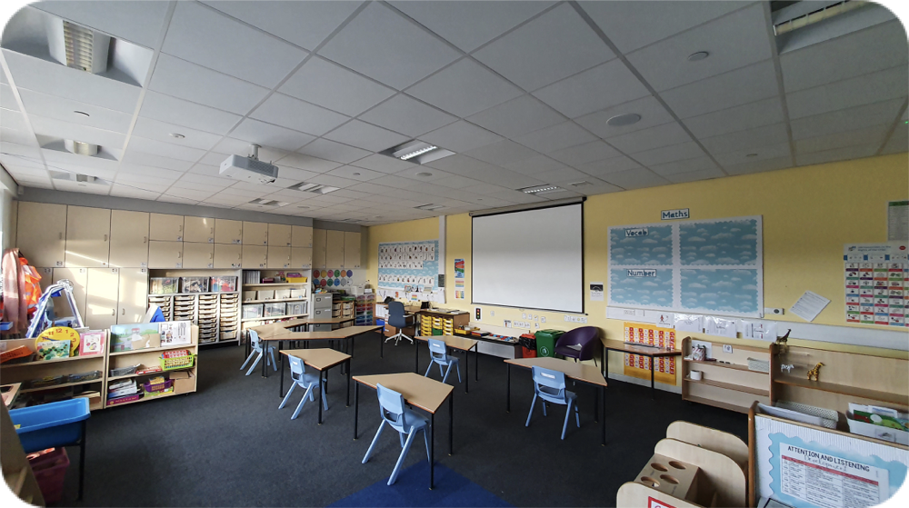
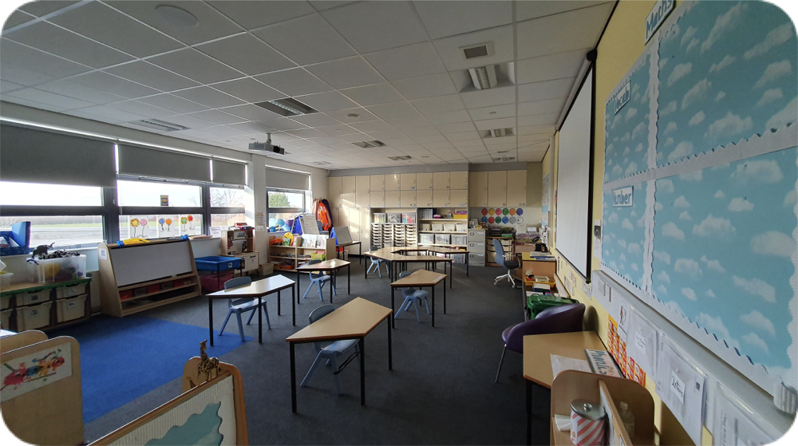
Language Hub Classes
Nepal Class
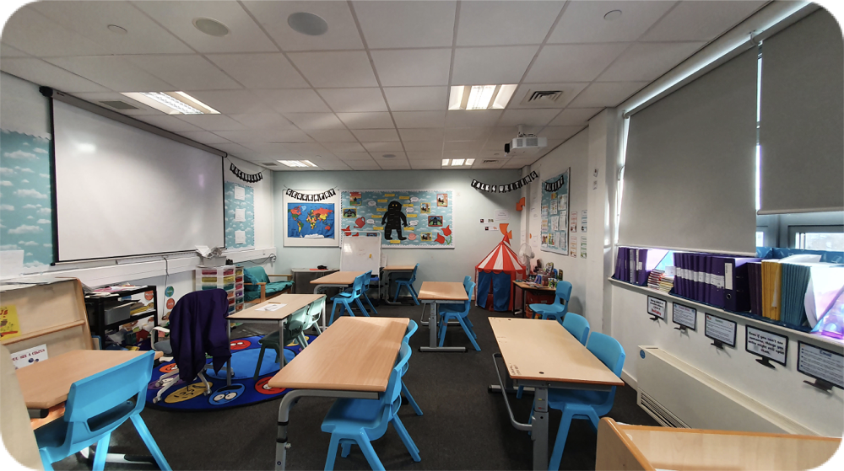
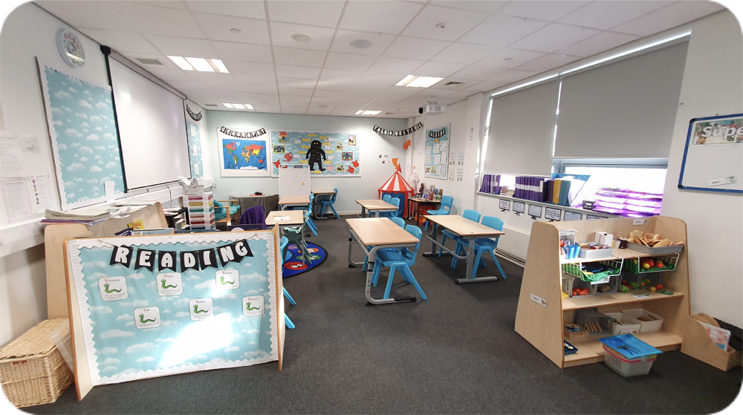
Language Hub Classes
Vietnam Class

Northwood Language Hub Protocol
Speech & Language Therapist identifies child to have a need which would benefit from intervention in the Language Hub Provision
Speech and Language Therapist completes report recommending Language Hub Provision. This is discussed with parent/carer and mainstream school.
Mainstream school complete Pupil Information Form and send this with evaluated communication plans / S&L therapy care plans for consideration at termly S&L placement panel.
S&L placement panel agrees to a place at the Language Hub.
Welcome meeting arranged for placement for the start of next term. Transport arranged with parents and/or LA transport officer.
Pupil remains on roll of mainstream school and commences placement at Language Hub. Formal reviews of progress will take place each term involving Northwood, mainstream school, S&L therapist and parents.
Following the review, it is either agreed for the placement to continue for another term or for the child to return full time to their mainstream school.
Before returning to mainstream, a transition meeting will be held and a plan of support agreed. This may include minimal S&L support following a successful placement or significant actions to offer further support in a different way e.g., ND pathway referral, EHCP application supported by Northwood.

